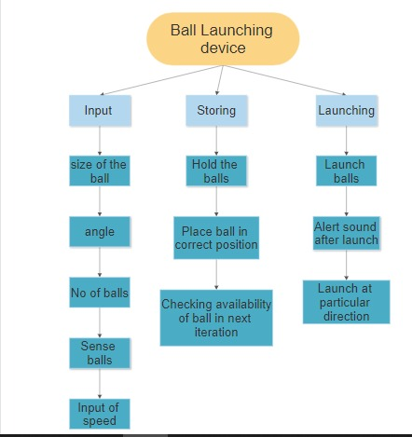**LAB 3 – P DIVISION.27/05/2021.**

**FILES:**

1. Mr. Ramesh is famous Sandalwood star. He now produces movies and serials. He wants to store his produced movie details in array of structures. Write modular C program to read the movie details from standard input device and store it in a file named “producedmovies.txt”. Read the stored movie details from file, store in the program and display all of the details on standard output device. As Mr. Ramesh has to pay the GST to the Government for the financial year 2020, help him to compute the total collection of money from movies released in 2020.

2. Girish uses online shopping app for purchasing the electronic products. He wants to purchase a smart phone. He looks at the details of smart phones and performs purchasing which has following specifications: mobile name, model, ram, internal memory, price, launch year. Considering at least for 10 different smart phone details,write a modular C program to perform the following:

a) Read from standard input device and store thesmart phone details in a file. (smartphone.txt)

b) Read smart phone details from file (smartphone.txt) and Display the smart phone with least price.

c) Read smart phone details from file(smartphone.txt) and Display the newest mobile launched.

**Dynamic Memory Allocation:**

3. Makemytrip app is providing following offers for booking trains through the app. For every 25th transaction for the customers, 50% discount on total ticket price. Write a modular c program to decide the customers who gets the offer.On 25/05/2021, N number oftransactions have been made by different customers, perform the following operations:

a) Allocate the memory using Dynamic Memory Allocation function(s), Read and Display all the train transaction details for different customers.

b)Display the customer names who gets the 50% discount with respect to their transaction number. (Transaction numbercan be repeated for different customers).

c) Compute the total amount in the form of discount that all the customers get.